Brie de Meaux’s Crepe
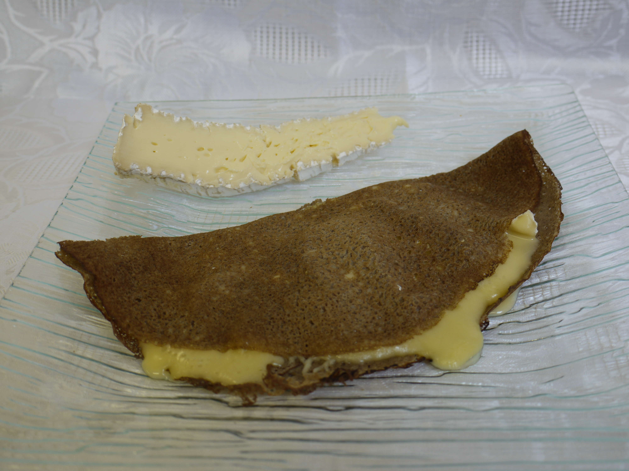
An original and delicious recipe

Let’s melt a little piece of butter in a pan,
put your crepe, add grated comté and
a slice of Brie de Meaux Rouzaire (1 cm).
Add a touch of liquid honey, fold back the crepe in half and wait for few minutes.

Serve with salad dressed with hazelnuts oil
to remind the typical taste of Brie.

A convivial, balanced and original meal
to share with your friends.

